Customer Behaviour & Revenue Optimization Analysis

- Project Overview
This project analyses the shopping behaviour of 3900 customers to understand what drives sales. The goal was to find patterns in people shop – with the factors involving age, gender, location, subscription and products. I used Python to clean and explore the data, SQL to answer the business questions.

2. Dataset Summary
- Rows: 3,900
- Columns: 18
- Key Features:
  - Customer Details: Age, Gender, Location, Subscription status.
  - Purchase Details: Item purchased, Category, Purchase Amount, Season.
  - Shopping Habits: Discount Applied, Review Rating, Shipping type.
- Missing Data: Found 37 missing values in the Review Rating column.

3. Data Cleaning and EDA (Python)
Before analyzing, I fixed a few issues in the dataset using Python:
- Missing Ratings: Some products had no rating. Instead of deleting them, I filled these gaps using the median rating of that specific category (so a missing "Clothing" rating got the "Clothing" average).
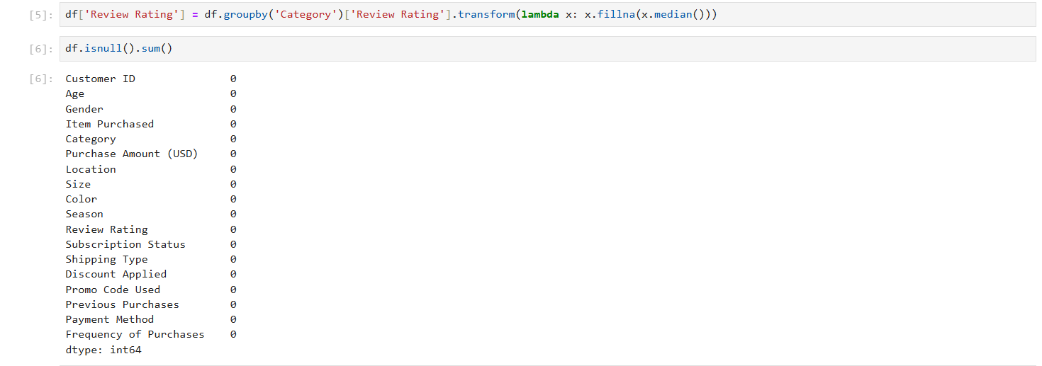
- Renaming Columns: I renamed the columns to make them consistent and easier to use in SQL (example: changed Purchase Amount (USD) to purchase_amount).
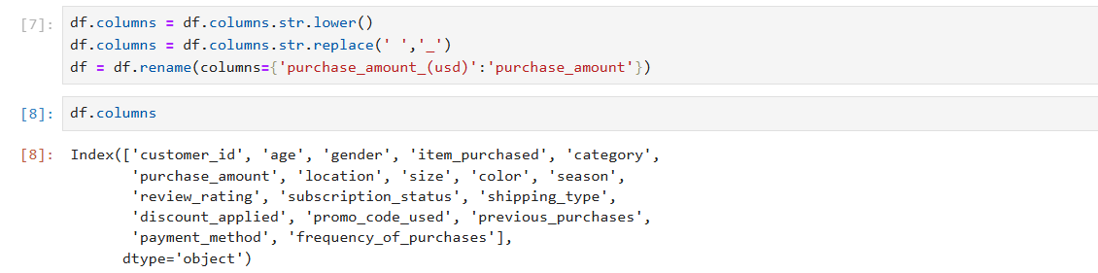
- New Columns: I created an age_group column to group customers (example: "Young adult", "Adult") for better analysis.

4. Data Analysis with SQL
Q1. What is the total revenue generated by make vs. female customers ?
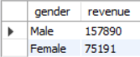

Q2. Which customers used a discount but still spent more rhan the average purchase amount?
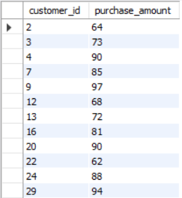

Q3. which are the top 5 products with the highest average review rating?
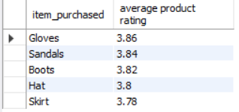

Q4. Compare the average purchase amounts between standard and express shipping.
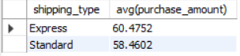

Q5. Do subscribed customers spend more? Compare average spend more and total revenue between subscribers and non-subscribers?
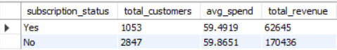

Q6. Which 5 products have the highest percentage of purchases with discounts applied?
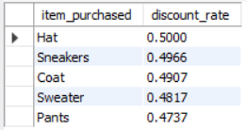

Q7. What are the top 3 most purchased products within each category?
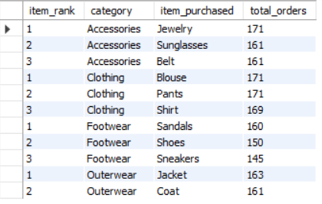

Q8. Are customers who are repeat buyers (more than 5 previous purchases) also likely to subscribe?
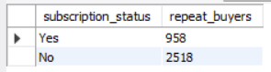

Q9. What is the revenue contribution of each age group? 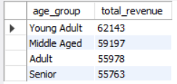

5. Business Recommendations
- Target the Young Adult Audience: Our data shows this group drives the most revenue, so marketing campaigns should be specifically designed to appeal to them.
- Change the Subscription Program: Since subscribers currently spend slightly less than non-subscribers, we need to add better perks to the program to encourage them to buy more.
- Prioritize "Class A" Inventory: Ensure the top-ranked products in Clothing and Footwear never go out of stock, as these specific items are keeping sales volume high.
- Promote Express Shipping: Encourage customers to select Express Shipping at checkout, as these buyers tend to purchase more items per order than standard shippers.

